Photosynthesis and Respiration Guided Viewing Homework
(Goes with the Bozeman Science video on my website, cedarridgescience.weebly.com.)
- The goal of life is to make________________.

- There are two strategies to get the glucose needed for respiration. _______________________ use photosynthesis (or chemosynthesis) to make their own glucose, while__________________________ have to consume other organisms to get the glucose they need.

- Copy the Concept Map that Mr. Andersen is showing below.

- Chemosynthesis occurs where there is no a lot of _______________________, like in the deep ocean.
- _________________________________ occurs when there is little/no oxygen available for respiration.
- Write the equation for photosynthesis below:

- During photosynthesis, energy is stored in _____________________.

- Photo-_________________________ (light reactions), synthesis-__________________(Calvin Cycle)

- Sketch the diagram that looks like this (Pause the video to see it with more detail): 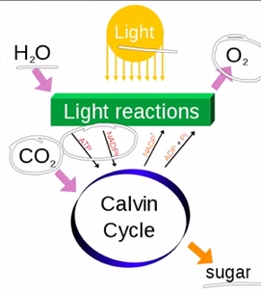

- Watch the light reactions & the Calvin Cycle to get an appreciation of how complex this process is. (You will not be responsible for knowing it in detail, but you will learn it in AP Bio.)

- Did the Earth’s atmosphere always contain as much oxygen as we have today?

- Where did the oxygen come from?

- Write the equation for respiration below:
- Glycolysis takes place in the _______________________.

- Energy is stored during the ______________________.

- In respiration , the electron transport chain takes place in the __________________________________ of the mitochondrion.

