Name_______________________ Date_____________________ Block _____

**Mastering Protein Synthesis**

**Protein Sequences**

In real life, ribosomes decode mRNA to make a protein sequence instead of a sentence. Determine the protein coded by this sequence of DNA through the processes of Replication, Transcription, and Translation. Use the codon chart at the bottom of this page to determine the correct amino acids for the protein.

**DNA Strand 1:**

ATG-GTT-ACA-GTC-TAT-TAG-ATG-CTA-TTT-ACT - TAG

DNA Strand 2: (DNA Replication):

_________________________________________________________________

mRNA Strand: (Transcription):

_________________________________________________________________

Protein Sequence: (Translation):

1. How many amino acids were made from this strand of DNA? _______
2. How many proteins were made from this strand of DNA? ________

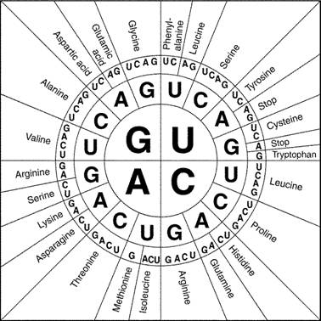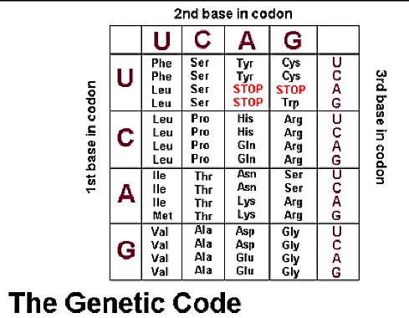**Codon Charts:** There are two versions of codon charts and you are responsible for knowing how to use both. Use the codons found in mRNA to find the correct amino acid. All of the amino acids will be linked together to make one protein. You may abbreviate the amino acids below by writing the first 3 letters. For example: Phenylalanine = Phe

**Concluding Questions:**

1. The process of making an exact copy of DNA is called _________________.
2. DNA is made of units called _________________________________.
3. The process of making a copy of RNA is called _______________________.
4. What is the function of mRNA? ____________________________________________________________.
5. What is the function of rRNA? ____________________________________________________________.
6. What is the function of tRNA? ____________________________________________________________.
7. What is a codon? ____________________________________________________________.
8. What is an anticodon? ____________________________________________________________.
9. What is the anticodon for CGA? ________________________.

10. The process of decoding messenger RNA to make proteins is called _______________.

11. Where does protein synthesis (translation) occur? ___________________.

1. What is a protein made out of? _________________________.

13. Why are proteins important? __________________________________.

14. What protein sequence is coded by the code UAG? __________________.

15. What would the amino acid be if there was a mutation and UAG was changed to UCG? _____________________.

16. What are the three differences between DNA and RNA?

**DNA**  **RNA**

* 1. Type of sugar: _________________ ____________________
  2. Structure: ____________________ _____________________
  3. Base Pairs: ____________________ ____________________