Gene Expression and Cell Differentiation
Gene Expression
- Each one of your cells contains the exact same copy of __________. Why do some cells produce different proteins than others?
- When a particular protein is made, a gene is being expressed.
  - Gene expressed = __________________________
- If a gene is not allowed to be expressed, then that protein will not be made.
  - Gene NOT expressed = ________________________
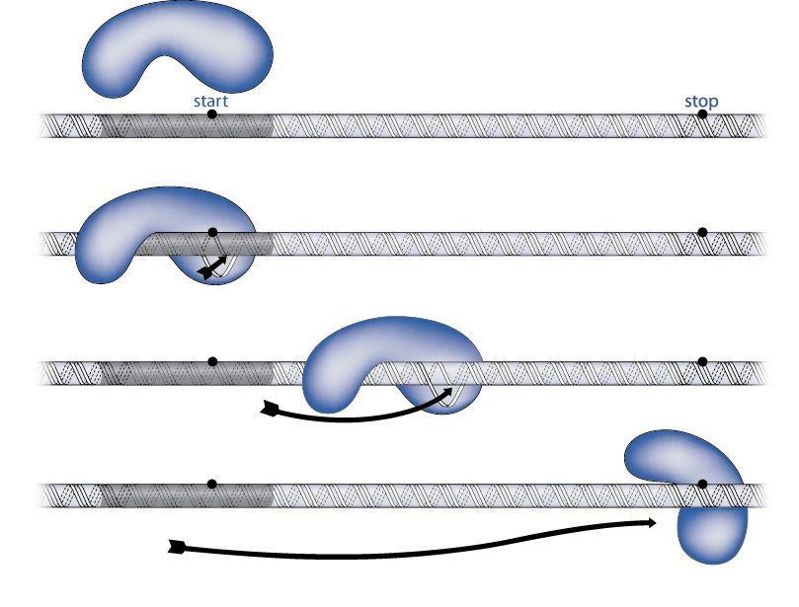
- Gene Regulation is a process where a cell determines which genes it will express and not express.
- In order for a gene to be expressed, an enzyme called
____________________________
must be able to bind to the DNA strand it
is trying to copy.
- RNA Polymerase can be blocked by a ____________________________which will not allow it to read and copy the DNA.
- When RNA Polymerase is ________________________ by the repressor, the gene will not be expressed.
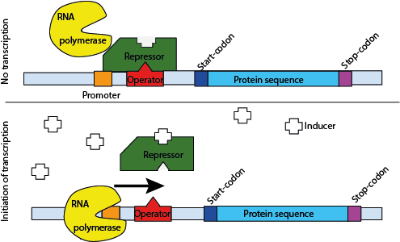

Cell Differentiation
- The ball of cells that you started off as is called a zygote. The cells of the zygote are called stem cells. Stem cells have the ability to __________________________________ into any kind of cell.
- After a week or two, the stem cells of the zygote start to differentiate, or take on specific __________________________. The zygote is now called an embryo.
- Cell Differentiation is the process directed by the DNA code for converting stems cells into more specialized cells in __________________________ organisms.
- A cell is specialized because of the ____________ ______________it produces that allow the cell to carry out specific functions.
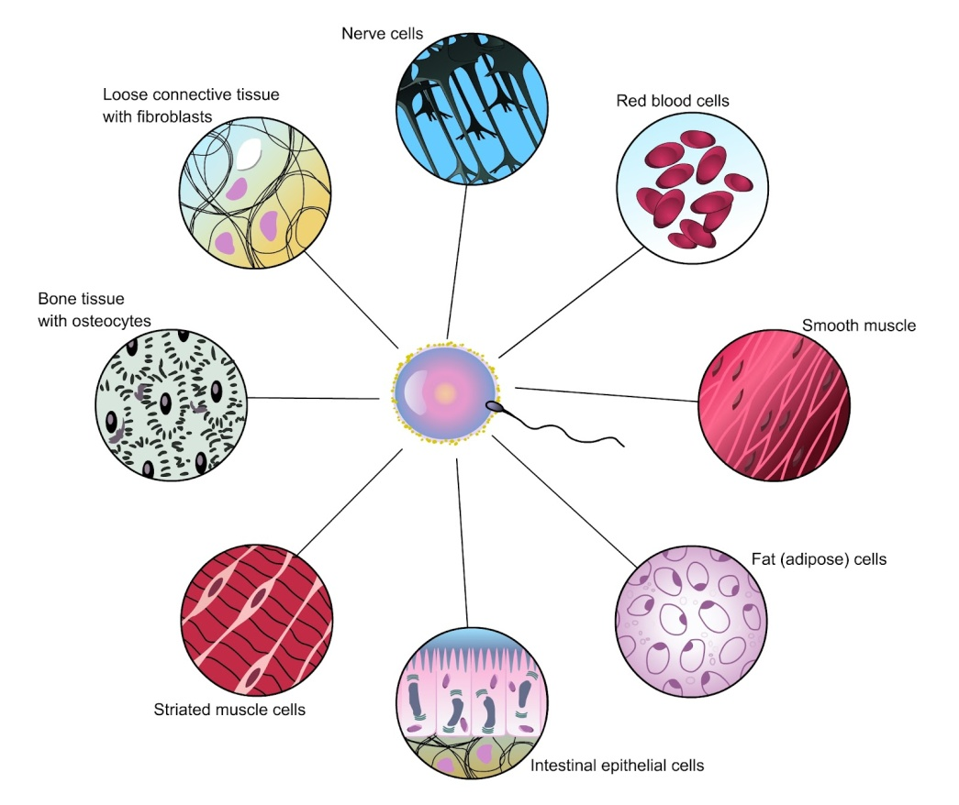
- Role of _________
  - DNA ____________ the code that determines which genes will be expressed to make a cell specialized
- Role of _________
  - RNA ______________ the code from DNA to ribosomes, and helps assemble the proteins that will make the cells become specialized
- Role of the ____________________________
  - Radiation, toxic chemicals, temperature, nutrition, and other factors can ____________ _________ causing changes in cell differentiation.
- Fetal Alcohol Syndrome is a condition that results from exposure to alcohol while in the womb. Not all exposure to alcohol will cause FAS, but symptoms can include physical and mental abnormalities.
- In sea turtles, gender is determined by the temperature of the sand during the third trimester of their development. Warmer sand tends to produce female turtles while cooler sand produces male turtles.

