Use these to help you study! You may need to create an account in order to use these, but it’s easy and FREE! DO IT!
- Ecology 1: https://play.kahoot.it/#/k/24c1a91d-dd87-4d94-b9f7-cc5502b939a4

- Ecology 2: https://play.kahoot.it/#/k/abb62d31-c019-4bb5-a817-39fcf3fb6638

- Biomolecules and Enzymes: https://play.kahoot.it/#/k/ae9d552d-61a5-4324-b41c-ed5c7c92c4a7

- Cell Structure and Specialization: https://play.kahoot.it/#/k/b61128d3-68e3-4335-86c0-7a37f93ad025

- Cell Processes and Energy: https://play.kahoot.it/#/k/0d96a29d-b31f-49ff-b0d6-4deb2b595a70

- Cell Cycle and DNA: https://play.kahoot.it/#/k/9ff9e3b4-9490-4531-971b-71596c674019

- Protein Synthesis, Mutations, and Gene Expression: https://play.kahoot.it/#/k/f13248e8-7ebc-477f-8861-9615e7442ac0

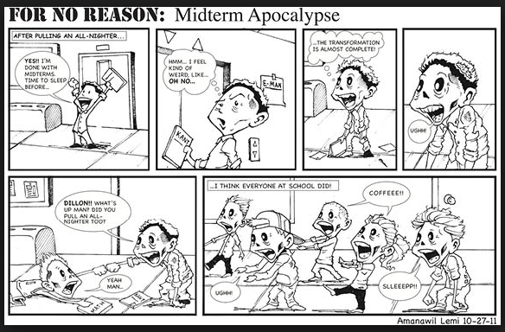
Don’t be these guys…study early and get a good night’s sleep! I BELIEVE IN YOU!

