Watson, Crick, & Franklin
- In 1953, Watson and Crick deduced the structure of DNA by using _________________
______________________________________________________________________
- Watson & Crick only figured out the structure, but relied upon the work of Rosalind Franklin who produce the photographs and crystals
- Watson & Crick received Nobel prizes, but Franklin didn’t since she had already passed away

DNA Structure
- DNA consists of two molecules that are arranged into a ladder-like structure called a ____________________________________
- A molecule of DNA is made up of millions of tiny subunits called __________________
- Each nucleotide consists of:

- The _________________________________________ form the backbone of the DNA molecule, whereas the bases form the “rungs”.
- There are _________________ types of nitrogenous bases.
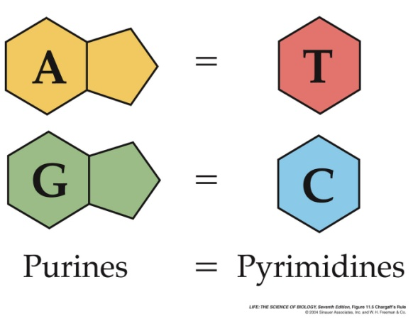

- In 1949, Chargraff determined that each base will only bond with one other specific base.
  - _______________________ (A)
  - _______________________ (T)
  - _______________________ (C)
  - _______________________ (G)
- Because of this complementary base pairing, the order of the bases in one strand ___________________________________________________________________________________________________________________________________________.
- The bases on one side of the helix form hydrogen bonds with the __________________ ________________ on the other side of the strand
- The order of nitrogenous bases on one chain for the DNA molecules is complementary to the order of bases on the opposite chain
- The order of nitrogenous bases of DNA is called its _____________________________

AAGCT

Why is complementary base pairing so important?

- The complementary nature of DNA helps explain how DNA replicates before a cell divides. _______________________________________________________________
______________________________________________________________________

