Normal Karyotypes:
Female:

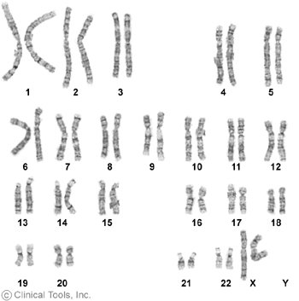

Male:
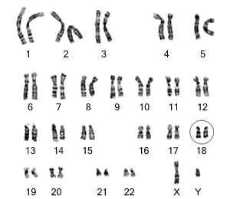

Genetic Disorders: Identifying Karyotypes
Read the passage below and underline what you think is the most important sentence.
A karyotype is an organized profile of a person's chromosomes. In a karyotype, chromosomes are arranged and numbered by size, from largest to smallest. This arrangement helps scientists quickly identify chromosomal alterations that may result in a genetic disorder. To make a karyotype, scientists take a picture of someone's chromosomes, cut them out and match them up using size, banding pattern and centromere position as guides. Today you will have the job as a cytogenticist, a person who studies karyotypes. You will be given 8 photos of different karyotypes of fetuses of different patients who are expecting a child. It will be your job to gather information from the karyotypes and fill out your report sheet so that you can give your report back to their primary physicians for further discussions.
Patient Karyotype # | Sex of Patient | Where is the chromosomal abnormality & is it a monosomy, trisomy, deletion, etc? | Name of Disorder Patient Will Have
Patient # 1
Patient # 2
Patient # 3
Patient # 4
Patient # 5
Patient # 6
Patient # 7
Patient # 8
Name______________________________ Date: ________________
Letter to Parents:
Write a letter to the parents of this unborn child. Tell them what you have discovered from their karyotype and what their child will be like. Give the parents some advice on how to help their child once it is born. This letter should be compassionate and caring to the parents and at least 10 sentences long. Use the sentence stems provided.
Dear Mr. & Mrs. ,
Techniques such as chromosomal analysis, or karyotyping, are used to study the genomes of organisms in order to ________________
_____________________________________________________________________________________________________________________________________.
I am sorry to say that after analyzing your unborn child’s chromosomes, it appears your child has____________________. We know this because we see _____________________________________ __________________________________________________________________
on your child’s karyotype .
Let me explain to you what to expect your child to be like. (Add 3 more sentences.) _____________________________________________________________________________________________________________________________________________________________________________________________________________________________________________________________________________________________________________________________________________________________________________________________________________________________________________________________________________________The mutation that caused this abnormality is called________________. This type of mutation occurs when_________________________________ _____________________________________________________________________________________. I am sorry to give you such bad news and will be available to answer any of your questions.

Sincerely,
Dr.______________________________

