APES Living World Test 2 Review
- Determine the diversity index using the Species Richness, Shannon-Weiner, and Simpson scales for the following populations. Show all work!!
Remember:
- Species Richness, R, is the number of different species.
- The Shannon-Wiener Diversity Index, H, is calculated using the following equation: H = – ∑ [(n_{i} / N) x ln(n_{i} / N)]
- The Simpson Diversity Index, D, is calculated using the following equation: D = 1 – ∑ [(n_{i} / N)²]

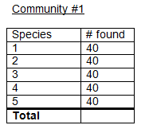

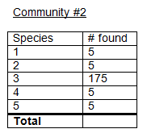

- Compare the diversity of the communities from #1 based on each of those three scales.

- What is the difference between species richness and evenness?

- What are the equations for photosynthesis and respiration?

- Where do the light-dependent and light-independent reactions of photosynthesis take place?

- The portion of photosynthesis directly responsible for the formation of glucose is —

- What are the three “steps” of cellular respiration?

- Which step produces the most ATP?

- How do photosynthesis and respiration contribute to the carbon cycle?

- The net annual primary productivity of a particular wetland ecosystem is found to be 8,000 kcal/m². If respiration
by the aquatic producers is 12,000 kcal/m² per year, what is the gross annual primary productivity for this ecosystem, in kcal/m² per year?

- What are the mechanisms of evolution?

- What factors affect the biodiversity on islands and habitat fragments?

- What does biodiversity provide us with?

- What is an allele? What is the source of new alleles?

- When faced with changing environmental conditions, what three possibilities do organisms have?

- Coevolution is defined as the influence of closely associated species on each other in their evolution. Name or look up an example of organisms who have coevolved with another organism.

- What are the three types of natural selection? Describe their effects on a population.

- What is fitness?

- Compare microevolution (changes in allele frequencies) and macroevolution (speciation).

- What is adaptive radiation?

- Describe artificial selection (AKA selective breeding).

- Do you think breeding current organisms with ancestral strains could help reduce problems with pests?

