- According to our notes, what is currently the Earth’s total fertility rate?

- According to the age-structure diagram below, approximately what percentage of people are ages 60 and older?

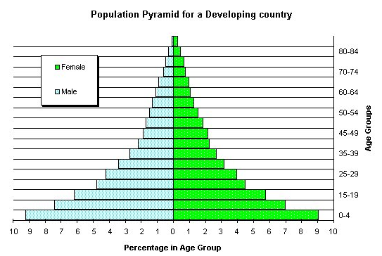

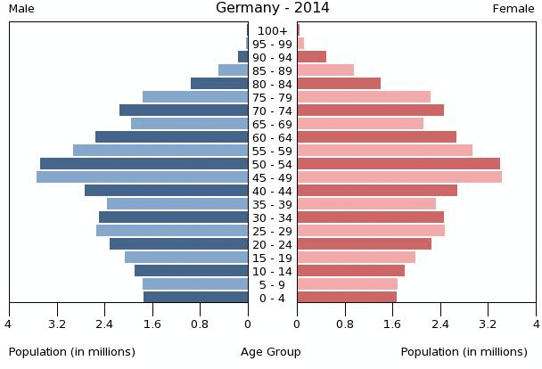
- To the right is the age-structure diagram for Germany. Describe what is happening to the population.

- If a population’s growth rate is 5%, what is its doubling time?

- The United States is not predicted to have a decrease in population size in the 21st century. Why?

- As demographic transition progresses, the total fertility rate of that population_______________________________.

- Despite the fact that population growth has slowed a bit globally, some environmentalists are still concerned about overpopulation. That’s because (choose one)
  - People are living longer
  - Fertility is decreasing
  - The standard of living is increasing

- What factor is most important in determining the shape of a species’ survivorship curve? (Remember the bubble lab.)

- Describe the following survivorship curves: (K-/r-selected? how much parental investment? Life span? Examples of organisms?)
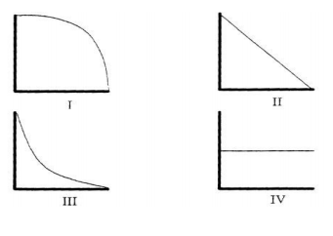

- If a population is at 5,000 individuals and is growing by 1.5% annually, how many individuals would be added by the next year? (show your work—no calculator!)

- If a population of 10,000 experiences 200 births, 80 deaths, 20 immigrants and 60 emigrants in the course of a year, what is the percent net annual growth rate? (Show work-no calculator!)

- Which of the following areas should have the highest number of births per woman: the Pactific islands, equatorial Africa, South America, or southeast Asia?

- Which region from #12 do you predict has the highest infant mortality rate?

- Describe the stages of the demographic transition model.

- If a population of 1 million has a growth rate of 2%, and it is expected to sustain that rate, what will the population size be in 140 years?

