APES- Chapter #7 Guided Reading
Biological Diversity

Name: ________________________________________________

Learning Objectives:
- How mutation, natural selection, migration and genetic drift lead to evolution of new species
- Why people value biological diversity
- How people can affect biological diversity
- How biological diversity may affect biological production, energy flow, chemical cycling, and other ecosystem processes
- What environmental major problems are associated with biological diversity
- Why so many species have been able to evolve and persist
- The concepts of the ecological niche and habitat

Read: Case Study: The Shrinking Mississippi Delta on Pg. 113

1: Which area of the continental U.S. has the most coastal wetlands?

2: What is happening to this area? What is causing these issues? Explain.

3: Why are large rivers like the Mississippi River considered to be land builders? Explain.

4: List the organisms that are affected by wetland loss in the Mississippi River Delta.

5: Why are the Mississippi River Delta issues so complicated? Why are some people opposed to making changes to save the wetlands?

6: Define Biological Diversity:

7: Define and explain the theory of Biological Evolution:

8: Summarize how mutations can affect biological diversity:

9: What are the 4 primary characteristics of natural selection and explain how it contributes to biological diversity.

10: Explain how migration and geographical isolation can contribute to the development of new species.

11: Define genetic drift and explain how it differs from the other mechanisms of biological evolution.

12: Define the following:

- Genetic Diversity:

- Habitat Diversity:

- Species Diversity:

- Species Richness:

- Species Evenness:

- Species Dominance:

13: How many species are alive on Earth today? Why is this number not easily defined?

14: Explain the ‘Competitive Exclusion Principle” using the example of the American Gray Squirrel and the British Red Squirrel.

15: Explain the concept of ecological niches using the diagram below:

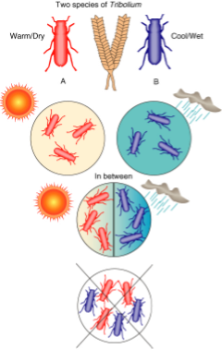

16: Explain the difference between a fundamental temperature niche and a realized temperature niche using the flatworm example.

17: Explain the concept of Symbiosis and obligate symbionts using the diagram below:

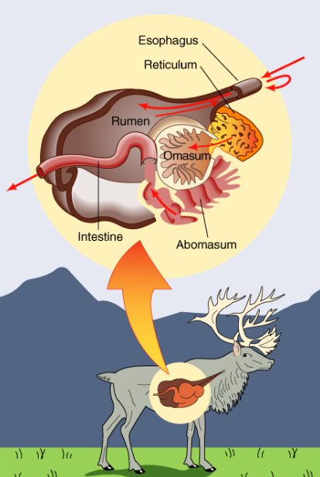

18: What is the difference between predation and parasitism? Explain using examples.

19: On T-Chart below- list the factors that tend to increase and factors that decrease biological diversity.

 | Factors that INCREASE diversity | Factors that DECREASE diversity
1
2
3
4
5
6
7
20: Using the picture below- explain the concept of an ecological gradient.
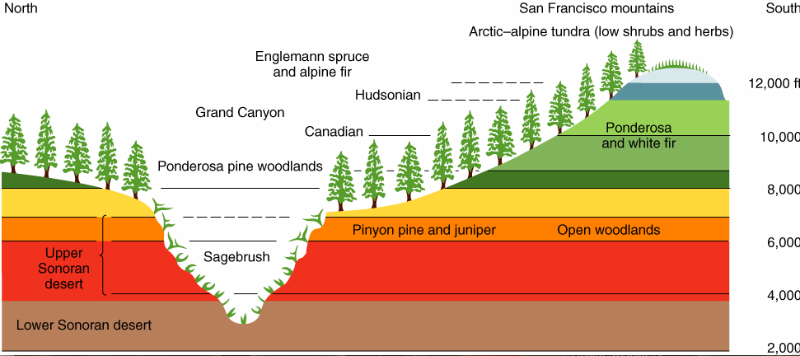

Study Questions:

21: Why do introduced species often become pests?

22: You are going to conduct a survey of national parks. What relationship would you expect to find between the number of species of trees and the size of the park?

