CELL INTRODUCTION

CELLS:
Cells are the structural and functional units of life and are the lowest level of structure than can perform all activities required for life. There are two different types of cells: Prokaryotic and Eukaryotic Cells. Cells are small because small cells have a higher surface area to volume ratio compared to bigger cells. Cells need a larger surface area to get nutrients and oxygen from the environment and to dispose wastes.
CELL THEORY (1840s):
- All living things are made of cells.
- The cell is the basic unit of organization of organisms.
- All cells come from existing cells.

PROKARYOTIC CELLS:
Prokaryotic cells are very small simple cells. These are the 1st type of cells found on Earth approximately 3.5 BYA. These cells do not have a nucleus or membrane bound organelles but do have nucleic acid. Some examples of prokaryotic cells are cyanobacteria (algae) and bacteria like E. coli and salmonella, which in the Kingdome Eubacteria and Archaebacteria.

EUKARYOTIC CELLS:
Eukaryotic cells appeared on earth approximately 1.5 BYA. These cells contain many membrane bound organelles including a nucleus. There are two types of eukaryotic cells, animal and plant cells, are found in all the other kingdoms (plant, animals, protists, and fungi).

CELL INTRODUCTION

CELLS:
Cells are the structural and functional units of life and are the lowest level of structure than can perform all activities required for life. There are two different types of cells: Prokaryotic and Eukaryotic Cells. Cells are small because small cells have a higher surface area to volume ratio compared to bigger cells. Cells need a larger surface area to get nutrients and oxygen from the environment and to dispose wastes.
CELL THEORY (1840s):
- All living things are made of cells.
- The cell is the basic unit of organization of organisms.
- All cells come from existing cells.

PROKARYOTIC CELLS:
Prokaryotic cells are very small simple cells. These are the 1st type of cells found on Earth approximately 3.5 BYA. These cells do not have a nucleus or membrane bound organelles but do have nucleic acid. Some examples of prokaryotic cells are cyanobacteria (algae) and bacteria like E. coli and salmonella, which in the Kingdome Eubacteria and Archaebacteria.

EUKARYOTIC CELLS:
Eukaryotic cells appeared on earth approximately 1.5 BYA. These cells contain many membrane bound organelles including a nucleus. There are two types of eukaryotic cells, animal and plant cells, are found in all the other kingdoms (plant, animals, protists, and fungi).

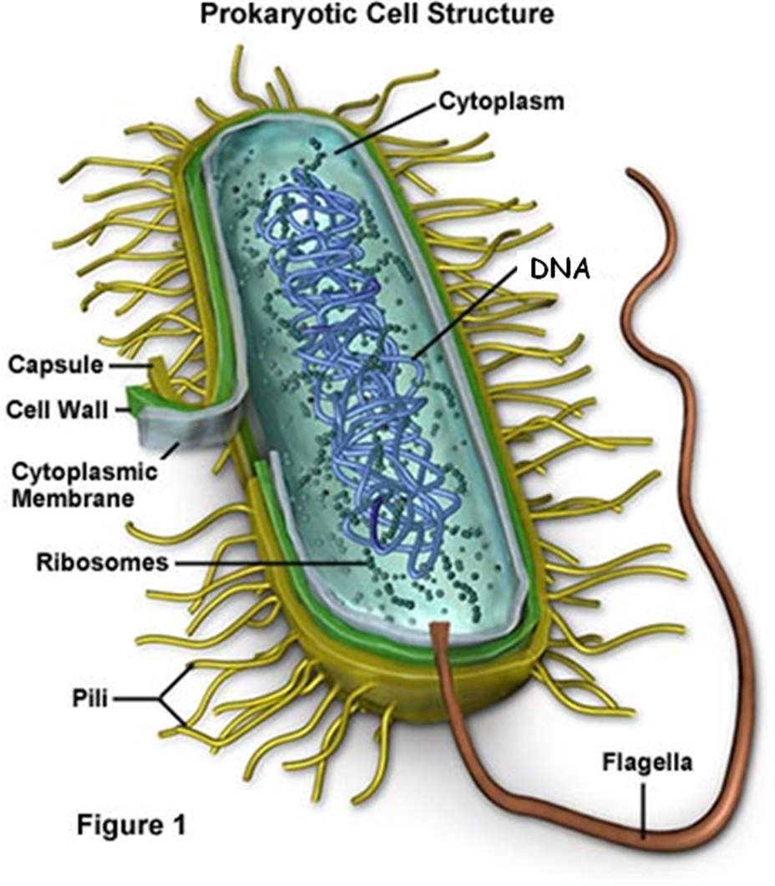
CELLS
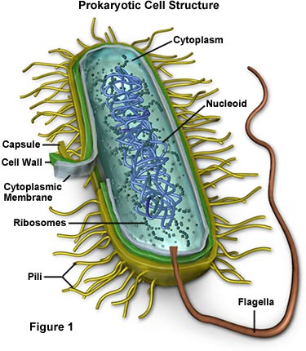
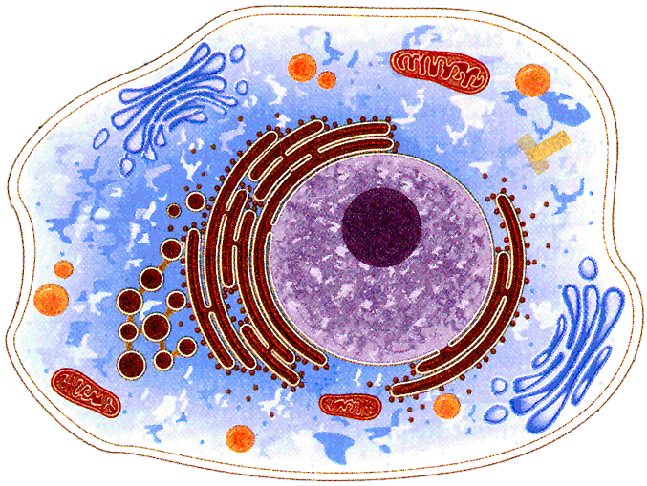

CELLS:
What are cells?

Why are cells so small?

Why do cells need a large surface area?
CELL THEORY:
“Cell Theory” was developed in the ____________. It has three statements.
1.

2.

3.
PROKARYOTIC CELLS:
What types of cells are Prokaryotic Cells?

When did Prokaryotic Cells appear on Earth?

What are some characteristics of Prokaryotic Cells?

What are some examples of Prokaryotic Cells and what kingdoms do they belong to?

EUKARYOTIC CELLS:
What type of cells are Eukaryotic Cells?

When did Eukaryotic Cells first appear on Earth?

What are some characteristics of Eukaryotic Cells?

What are some examples of Eukaryotic Cells and what kingdoms do they belong to?

