PAGE # _______
NOTES – CHARACTERISTICS OF LIVING THINGS
Living things must meet all 8 characteristics listed below.
- Living things are made of cells.  Are _____________________________ and organisms can be  - Unicellular - _________ _________; single cell.  - ___________________ - many celled. | 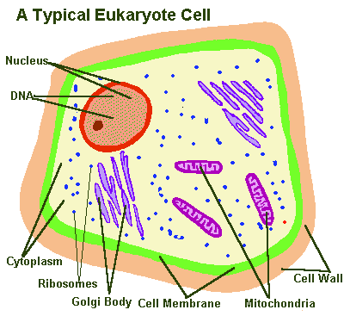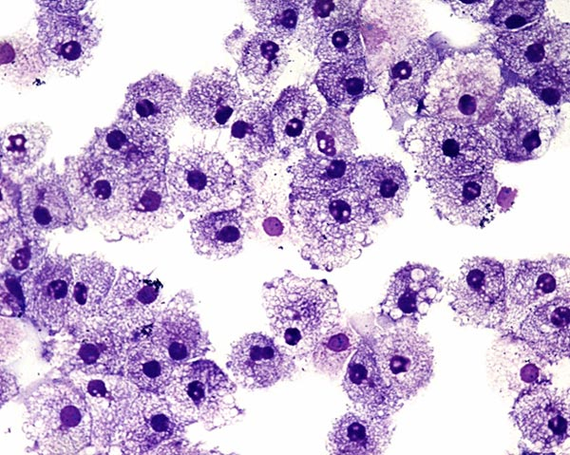
- Living things reproduce.  - Asexual - ____________ has a ___________ parent.  - __________________ - two cells from __________________ _________________ unite to produce 1st cell of organism.  ____________ ________________ form. | 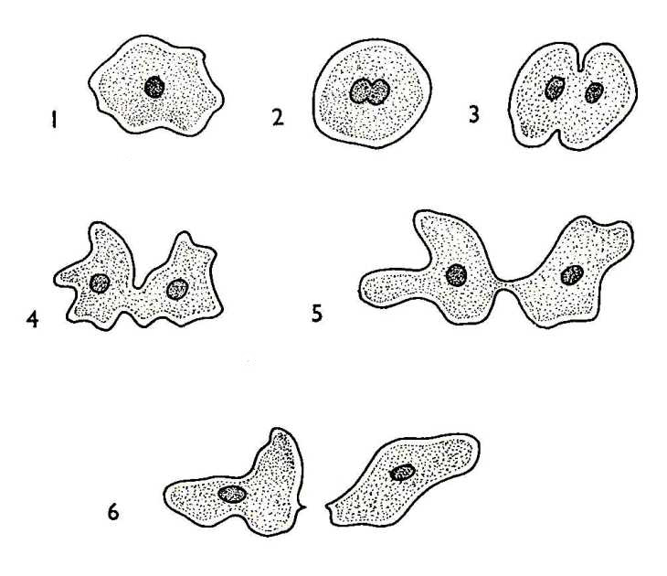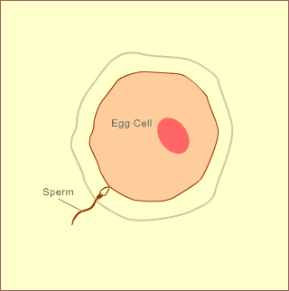  Asexual Sexual  Reproduction Reproduction
- Living things are based on a universal genetic code.  Is based on a _________________  _____________ _______________ (DNA)  that determines __________________  __________________ of every organism on Earth. | 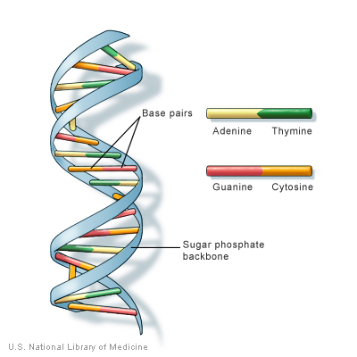
- Living things grow and develop.  ______________ and develop.  - At some point _______________ in size.  - Organisms change (__________________) over the course of their _________time. | 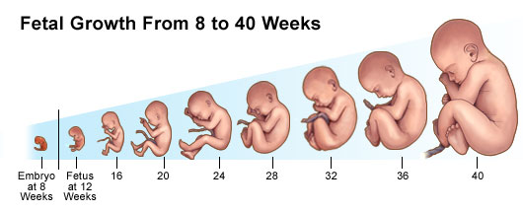
- Living things obtain and use energy.  Obtains and ________ __________________ and energy.  - Need these to _________ ____________ alive.  - Need constant ___________ ____ __________ _______ ________________.  - Definition: _________________ - combination of __________ ____________ _________________ in the body that builds or ________________ ________ materials as it carries out its life function. | 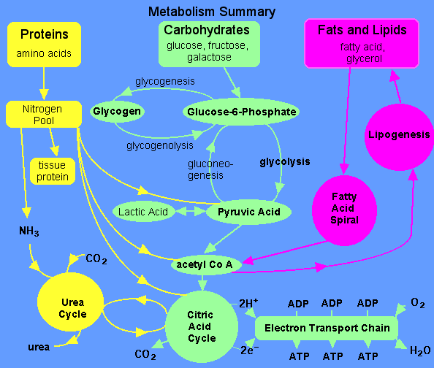
- Living things respond to their environment.  ________________ ______ their environment.  - Organisms _____________ and respond to ____________ in their environment.  - Definition: stimuli - ___ _______________  _____ ____________ an organism responds.  - Can be external or internal. | 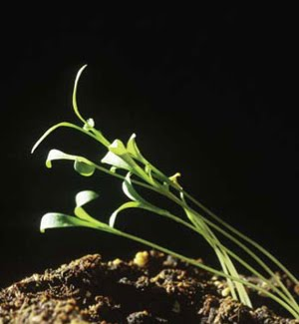
- Living things maintain a stable internal environment.  Maintain a ____________ ______________ environment.  - _____________ to do this is known as homeostasis.  - Often involves ___________ ____________  mechanisms. | 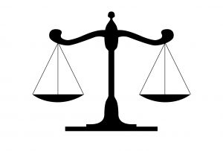
- Living things change over time.  Taken as a group _________________ __________ _________ ___________;  these changes are _____________ at any one time but over ___________ ___________ ____ _________ can be significant. | 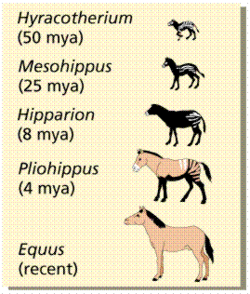
LEVELS OF ORGANIZATION
